PROJECT REPORT
Project Title: Online Complaint Registration and Management System
Team Members:
- M Balachandar – Full Stack Developer
Project Description:
The Online Complaint Registration and Management System is a web-based platform that allows customers to register complaints regarding products or services, track their status, and communicate with customer support agents. It streamlines complaint handling and ensures transparency between users, agents, and administrators.
Project Overview
• Purpose
The purpose of this project is to create a digital platform where customers can easily register complaints regarding products or services and track their resolution status in real time. The system aims to eliminate manual complaint handling, reduce delays, and improve customer satisfaction through structured and transparent communication between users, agents, and administrators.
• Features
- User Registration and Secure Login
- Complaint Submission and Tracking
- Admin Dashboard for Complaint Assignment
- Agent Dashboard for Complaint Handling
- Real-time Chat between User and Agent
- Email Notifications for Complaint Updates
- Role-Based Access (User, Agent, Admin)
- Secure Password Encryption
- Centralized Complaint Database

Architecture
• Frontend (React)
The frontend is developed using React.js, which provides a component-based architecture for building reusable UI elements. React Router is used for navigation, while Axios is used to communicate with backend APIs. Bootstrap or Material UI libraries are used for responsive design and styling to ensure a smooth user experience across devices.
• Backend (Node.js & Express.js)
The backend is built using Node.js with the Express.js framework. It handles business logic, API requests, authentication, complaint processing, and email notifications. Middleware such as CORS and JSON parsing ensures secure and structured communication between client and server.
• Database (MongoDB)
MongoDB Atlas is used as a cloud-based NoSQL database. It stores user details, complaints, assigned complaints, chat messages, and OTP verification data. Mongoose is used for schema modeling and database interaction.

Setup Instructions
• Prerequisites
Before running the project, ensure the following software is installed:
- Node.js (v16 )
- MongoDB Atlas Account
- Git
- Code Editor (VS Code )
- Web Browser (Chrome )
Installation Steps
- Clone the repository
- git clone
- Navigate into project folders
- cd client
- cd server
- Install dependencies
- npm install
- Create .env file in server folder and add:
- MONGO_URL=your_mongodb_url
- EMAIL_USER=your_email
EMAIL_PASS=your_app_password
Save files and proceed to running the application.
Folder Structure
• Client (React Frontend)
- src/ – Contains components, pages, services, and styles
- components/ – Reusable UI elements
- pages/ – Dashboard, Login, Signup, Complaint Form
- services/ – API calls using Axios
- App.js – Main routing configuration
• Server (Node Backend)
- config/ – Database connection files
- models/ or schemas/ – MongoDB schemas
- routes/ – API endpoint definitions
- utils/ – Helper functions like email service
- server.js / app.js – Main backend entry point

Running the Application
Frontend
Open terminal in client directory:
npm start
Backend
Open terminal in server directory:
npm start
The frontend typically runs on http://localhost:3000 and backend on http://localhost:8000.
API Documentation
The backend exposes several RESTful APIs for user registration, login, complaint submission, complaint tracking, agent assignment, chat messaging, and status updates. Each endpoint handles specific request methods such as GET, POST, PUT, or DELETE, and returns structured JSON responses. These APIs form the bridge between frontend and backend communication.
User APIs
- POST /SignUp – Register a new user
- POST /Login – Authenticate user credentials
Complaint APIs
- POST /Complaint/:id – Submit complaint
- GET /status/:id – View user complaints
- PUT /complaint/:complaintId – Update complaint status
Admin & Agent APIs
- GET /AgentUsers – Fetch agents
- POST /assignedComplaints – Assign complaints
- GET /allcomplaints/:agentId – View agent complaints
Message APIs
- POST /messages – Send chat message
- GET /messages/:complaintId – Retrieve messages
Example Response:
{
"message": "Complaint Registered Successfully"
}

Authentication
User authentication is managed through email and password verification, with passwords securely encrypted using hashing techniques like bcrypt. Role-based authorization controls access to different dashboards such as admin, agent, and user.

Authentication is handled using email and password verification.
- Passwords are encrypted using bcrypt hashing.
- Role-based authorization restricts dashboard access.
- Sessions or tokens can be added for enhanced security in future versions.

Screenshots or Demo
- Landing Page

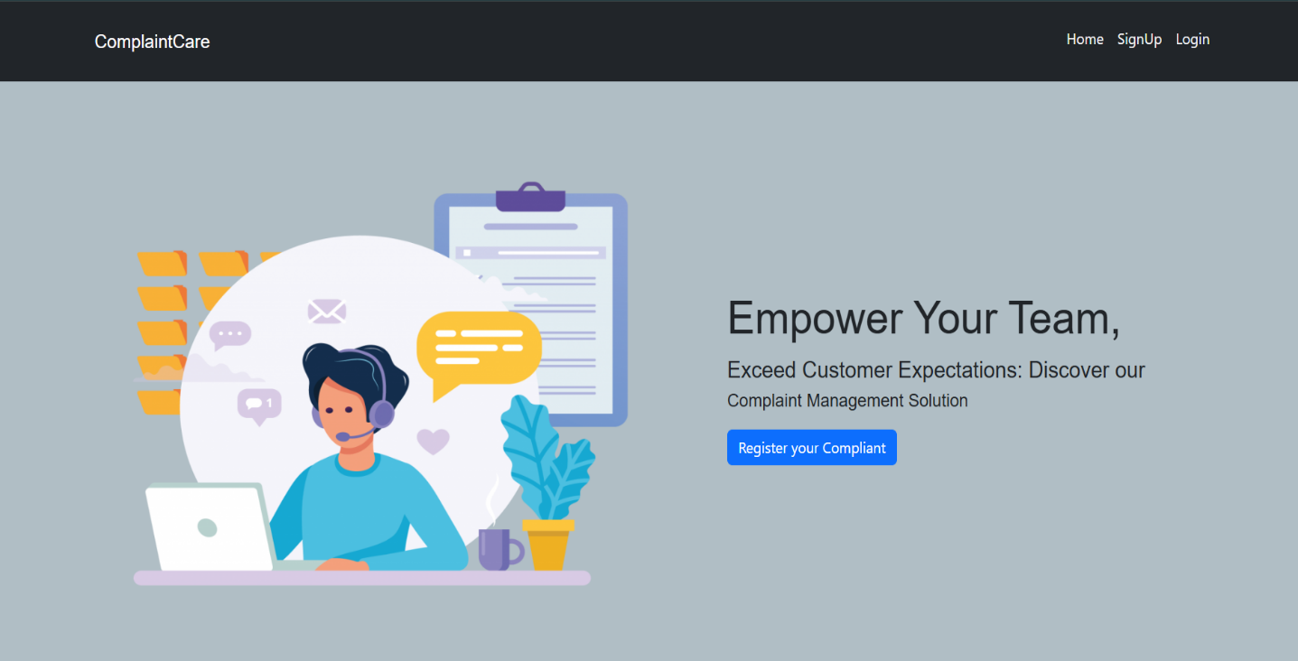

- Registration Page

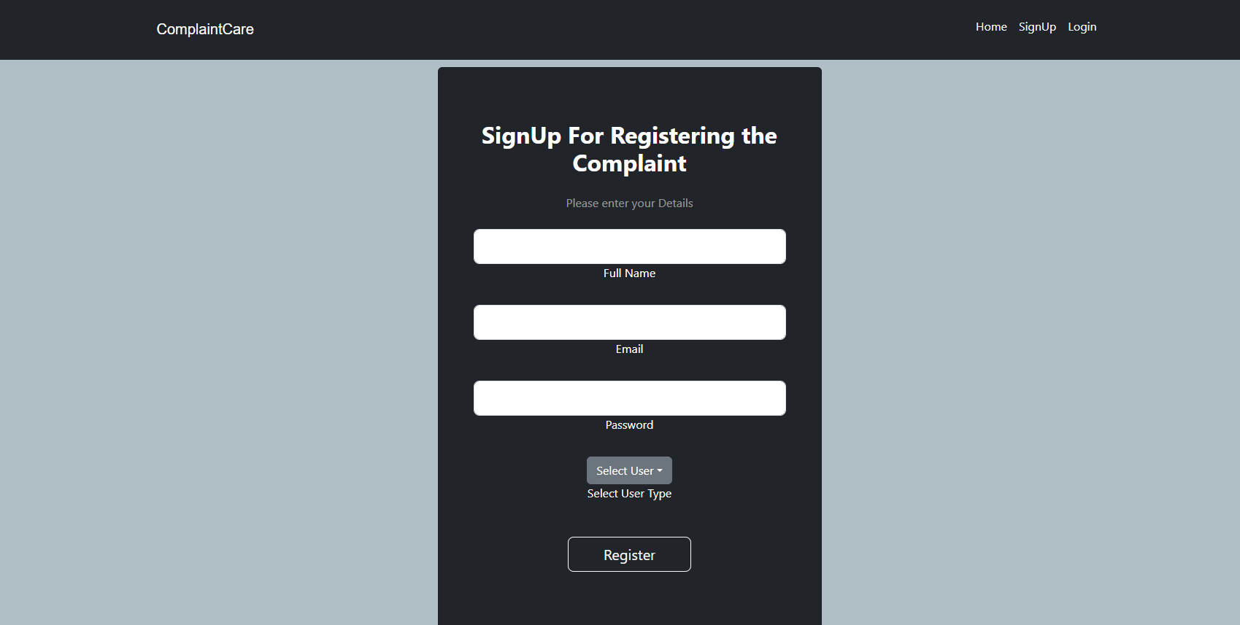

- Dashboard For Complaint

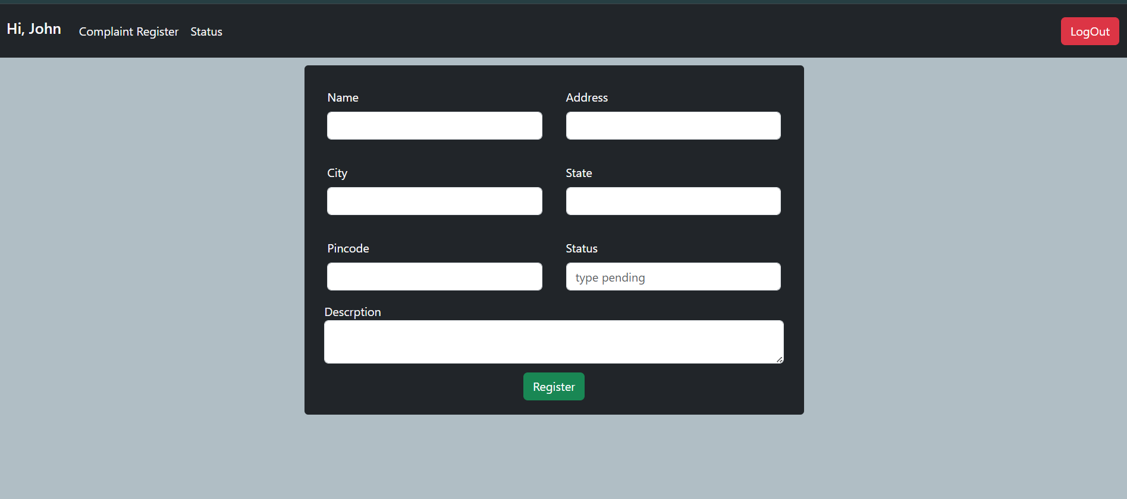

- Admin Dashboard

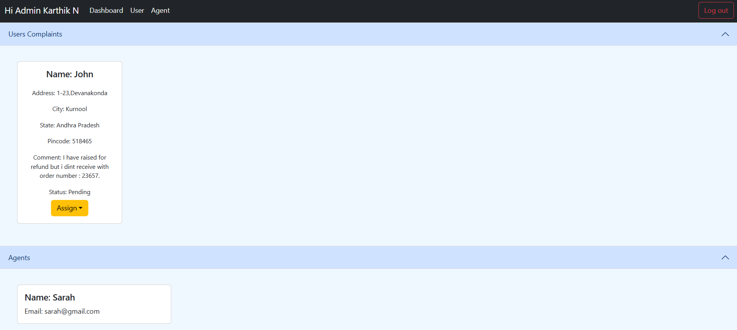

After assigning to the Agent
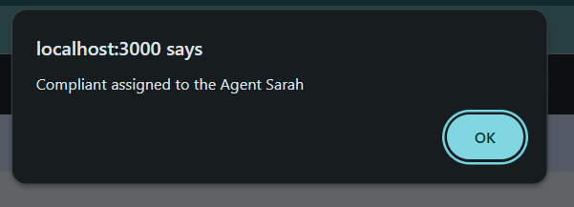

- Agent Dashboard

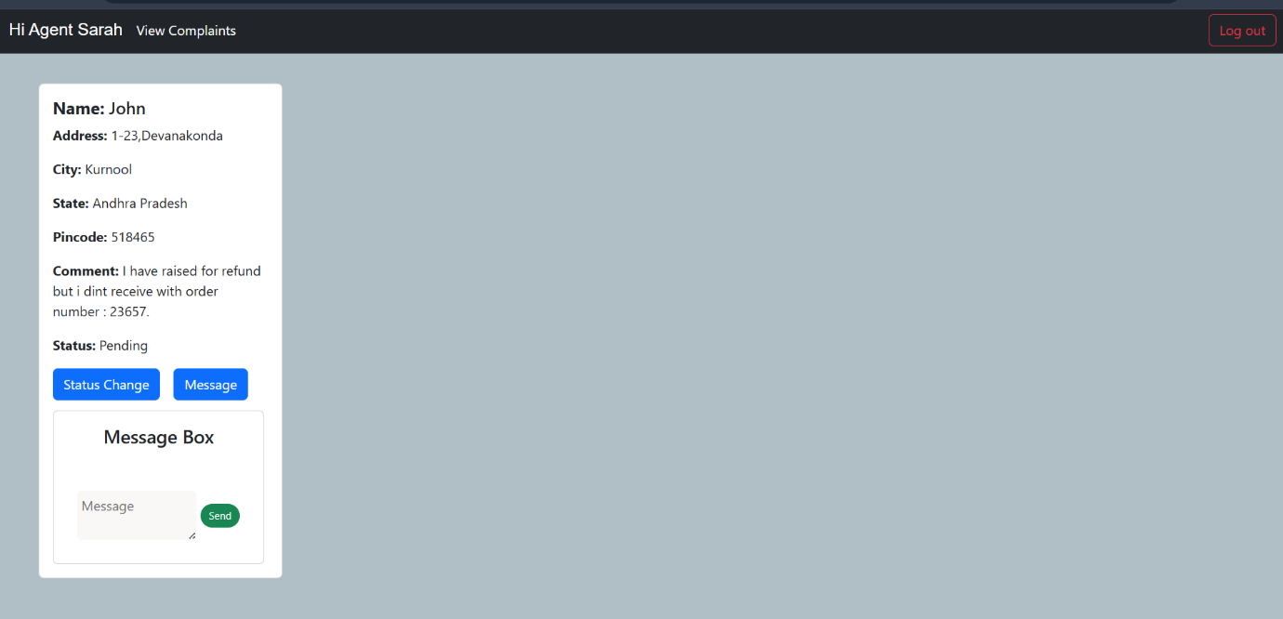
- After resolving the problem
From user side:
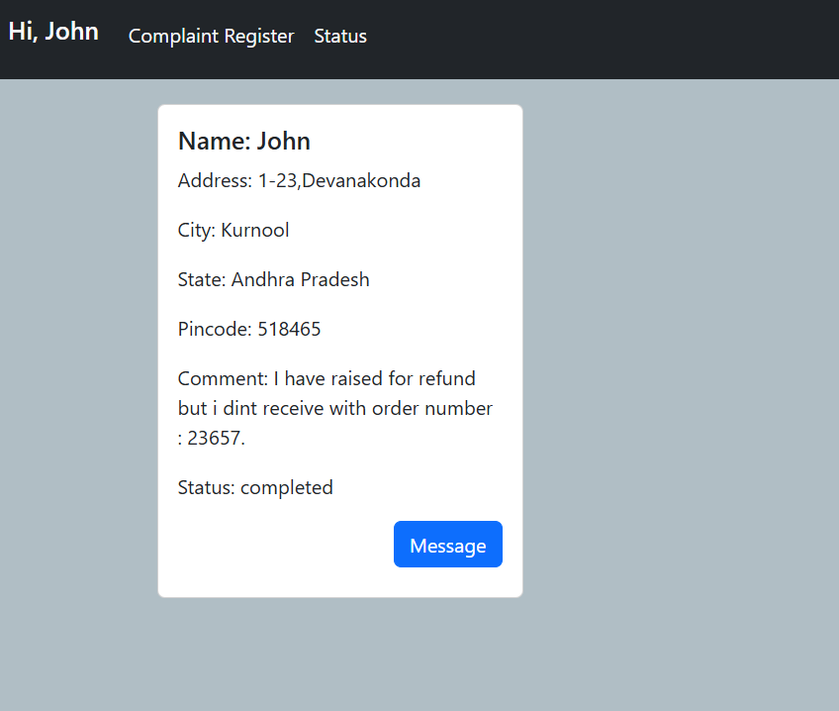

From Agent side:
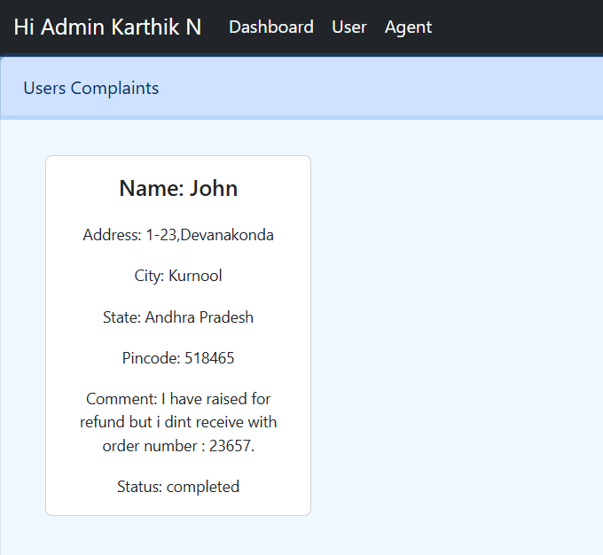

Known Issues
- Email OTP may fail if email credentials are incorrect
- Limited analytics dashboard
- No SMS notifications
- Mobile responsiveness can be improved
Some minor limitations may include occasional email notification failures due to incorrect credentials, limited analytics features, or improvements needed in mobile responsiveness. These issues do not affect core functionality but can be enhanced in future updates.

Future Enhancements
- Mobile Application Development
- AI-based Complaint Categorization
- SMS & Push Notifications
- Multi-Language Support
- Advanced Analytics Dashboard
- File Upload Cloud Storage Integration

Future improvements may involve developing a mobile application version, adding SMS and push notifications, implementing AI-based complaint categorization, integrating cloud storage for file uploads, supporting multiple languages, and building advanced analytics dashboards. These enhancements would further increase scalability, accessibility, and overall user experience of the system.

Project GIT repository link: https://github.com/MDMBC/resolvenow-your-platform-for-online-complaints/tree/main

Project DEMO link: https://drive.google.com/file/d/1VmcGFxjBxV5-vnPNG9tBIqAyKhiidZKg/view?usp=drive_link

